Building accessibility checklist

**Public transportation**



Public transportation stops should be less than a 10-minute walk way. Once you get off the public transportation, you should be able to walk to the place in 10 minutes or less.

1. **Is it easy to arrive to the building with public transportation?**

Yes  No

1. **Which types of public transportation can you take?**

Bus  Train  Metro

Other Click or tap here to enter text.

1. **How long will it take you to reach the building after you get off the station?**

**Time in minutes** Click or tap here to enter text.

**Reaching the building**

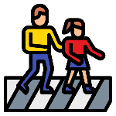

1. **Are there any places in the way between the stop and the building to sit?**

Yes  No

1. **Are there crossings to help you cross the road safely?**

Yes  No

1. **Are the pavements uneven and bumpy?**

Yes  No

1. **Do you have to walk across cobbles to get to the building?**

Yes  No

1. **Do you have to walk up or down any hills to get to the building?**

Yes  No

**Entrance of the building**

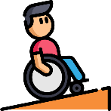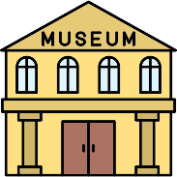

1. **Are visitors with a disability able to enter the building by the same entrance as other visitors?**

Yes  No

1. **If not, is there another entrance that is accessible for all users?**

Yes  No

**On site accessibility**

1. **Is there any information on the web about the accessibility of the building?**

Yes  No

1. **Is there any contact to ask information about questions related to accessibility?**

Yes  No

1. **If open to the public, which of the following accessibility accommodations are available?**

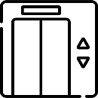   

Lift Clear Guidance Proper lighting Assistance dogs

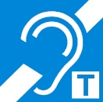  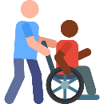

Induction loop Accessible toilets Wheelchair service

**Other** Click or tap here to enter text.

1. **If open to the public, which of the following accessibility services are available?**

  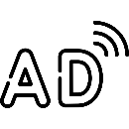 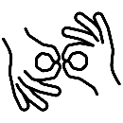

Text in braille Close captions/subtitles Audio description Sign language

 Text in easy to read and easy to understand languge

**Other** Click or tap here to enter text.

**Are all persons welcome?**



You can write, draw, take a picture, make collage or use any other medium!

Click or tap here to enter text.

